**Practical Assignment 2**

**21549967 Keelan Matthews**

**Task 1**

1.3 Template Method

**Task 2**

2.5 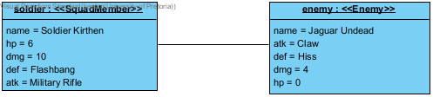

2.6 EnemyFactory is the Creator, and SnakeFactory, GorillaFactory, CannibalFactory and JaguarFactory are the Concrete Creators. Enemy is the Product and Gorilla, Snake, Jaguar and Cannibal are the Concrete Products. The createEnemy() method is used as the factory method.

2.7 Factory Method